XRP Analysis - 12-11-2025

Speedy Gonzalez @keepitcrypto
XRP Investor Tool - 2 Year MA
The Investor Tool was created as a tool for long-term investors, indicating periods where prices are likely approaching cyclical tops or bottoms. The tool uses two simple moving averages of price as the basis for under/overvalued conditions: the 2-year MA (green) and a 5x multiple of the 2-year MA (red).
- Price trading below the 2-year MA 🟢 has generated outsized returns, and signaled bear cycle lows.
- Price trading above the 2-year MA x5 🔴 has been signaled bull cycle tops and a zone where investors de-risk.
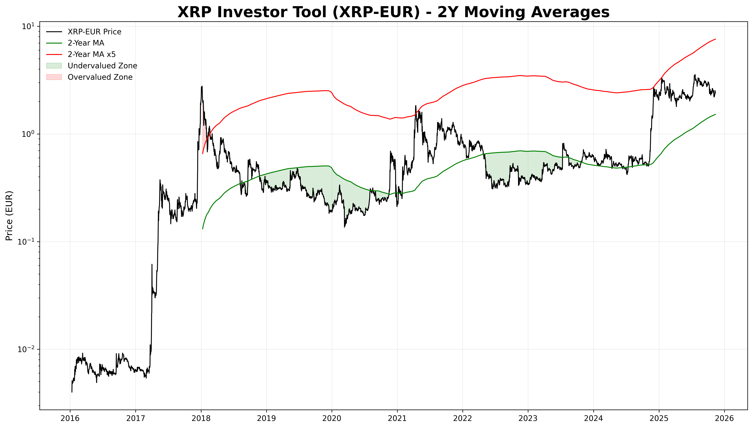
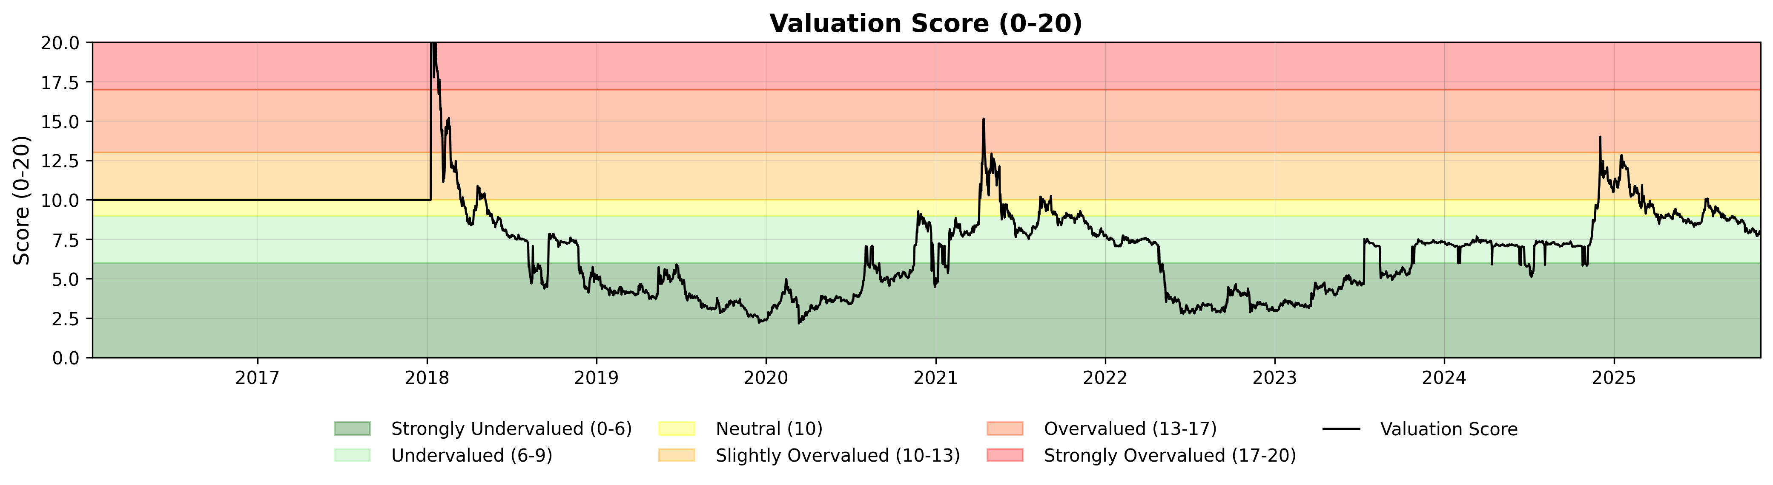

Current Market Status
As of 12-11-2025, Ripple is trading at €2.44.
Valuation Analysis
Our 2-Year Moving Average model indicates a valuation score of 7.91/20, suggesting that Ripple is currently **Undervalued**. The price is trading 60.4% above the 2-Year Moving Average.
- Support: €1.52 (2-Year Moving Average)
- Resistance: €7.59 (5x 2-Year Moving Average)

Ripple Pi Cycle Indicator Plot
The Pi Cycle Indicator works by comparing the momentum of two moving average indicators: the 111-day SMA 🔵 and the 2 * 350-day SMA 🟣. These two averages, with a ratio close to the Pi constant (3.1415), signal overbought or oversold conditions.
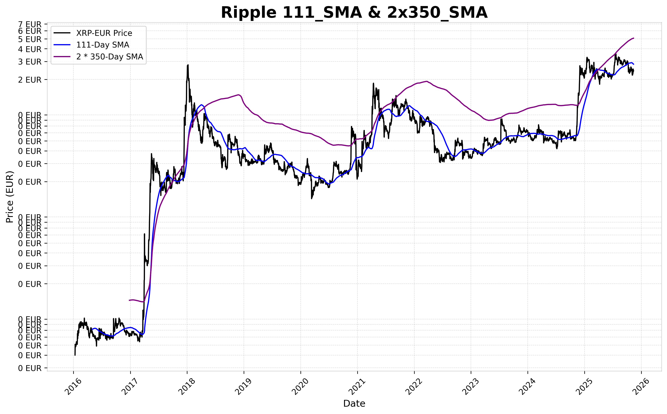
- When the 111-day SMA crosses above the 2 * 350-day SMA, it may indicate an overheated market, while a cross below suggests a cooling period. Highlighted areas show potential cyclical lows (green) and highs (red), based on oscillator values.
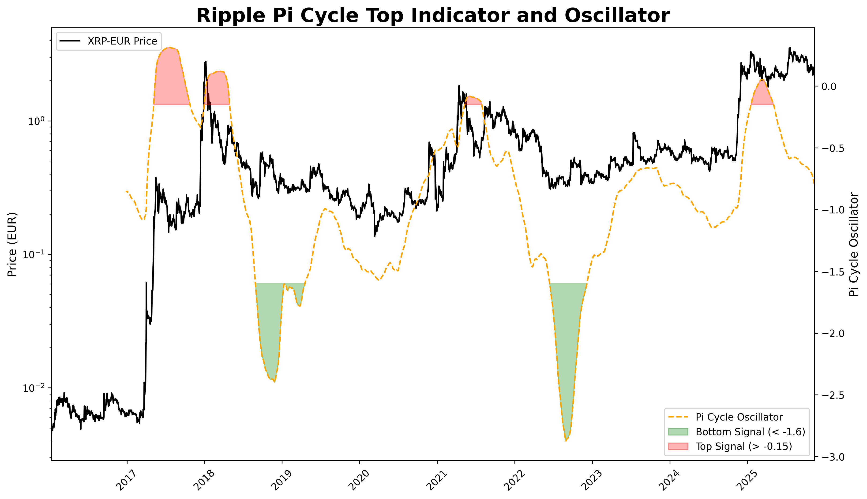
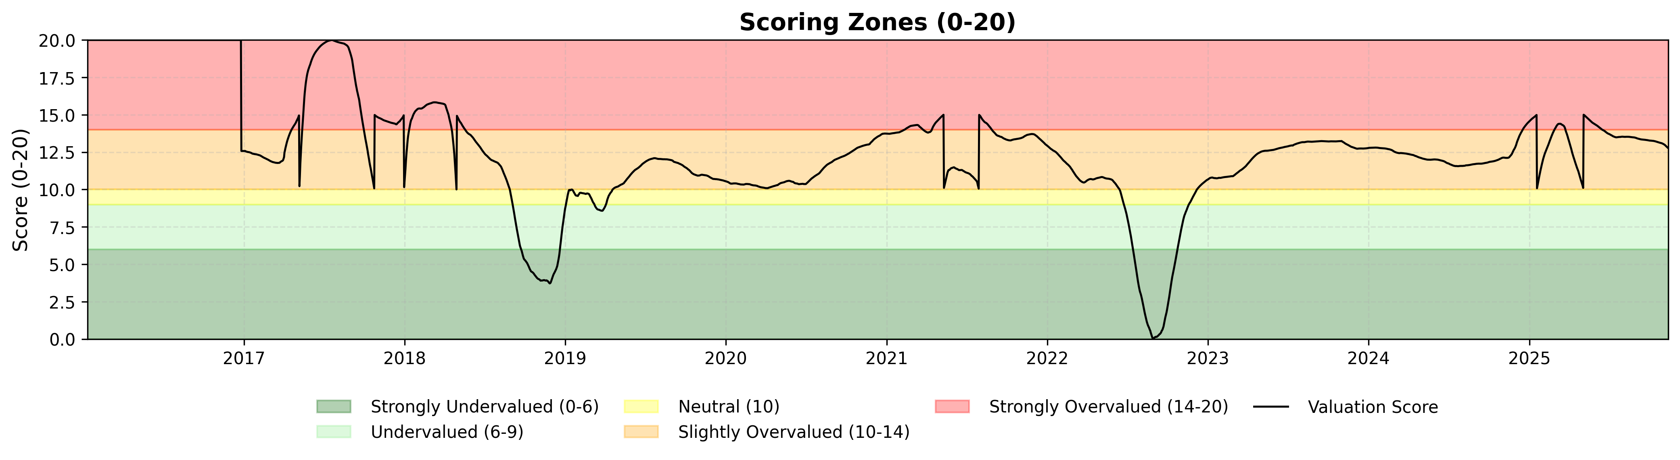
Technical Analysis
The Pi Cycle Oscillator is -0.80, indicating that Ripple is currently **Slightly Overvalued** with a valuation score of 12.78/20.

Ripple Mayer Multiple Model
The Mayer Multiple is an oscillator calculated as the ratio between price and the 200-day moving average (200DMA). The 200DMA is a widely recognized indicator for establishing macro bull or bear bias. The Mayer Multiple therefore represents a measure of distance away from this long-term average price as a tool to gauge overbought and oversold conditions.
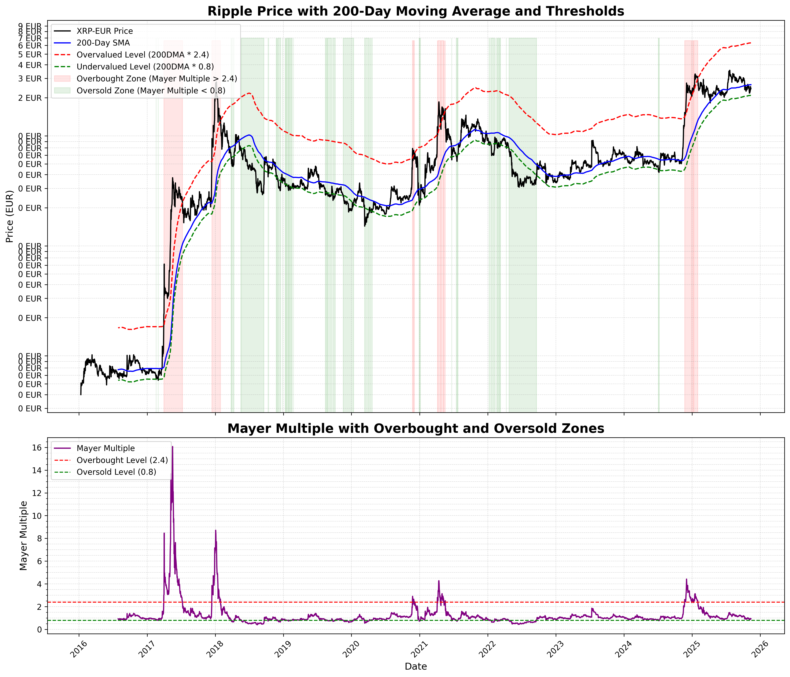
- Values below 0.8 (🟢) represent prices trading at a 20% discount to the 200-day MA, often indicating bear market lows.
- Values above 2.4 (🔴) represent prices trading at a premium of 240% above the 200-day MA, often indicating bull market peaks.
- The latest Mayer Multiple is 0.93.
- The 200-Day Moving Average is 2.63 EUR.
- The overvalued level (2.4x 200DMA) is 6.31 EUR.
- The undervalued level (0.8x 200DMA) is 2.10 EUR.

Total Average Score
$Total_Score=(Score_2yr_MA*0.2)+(Score_Pi*0.8)$
The Total Average Score for XRP-EUR, calculated using a weighted approach with 20% emphasis on the 2-Year Moving Average Indicator and 80% on the Pi Cycle Oscillator, is currently **11.80**. This score reflects a market condition categorized as **Overvalued**, indicating that the market is neutral.
